**BUS RESERVATION SYSTEM**

**Tables :**

create table bus(bus_name char(15) primary key,total_seats number(3),reserved_seats number(3), price number(3));

create table busreservation(bus_name char(15) references bus_details(bus_name),seat_id number(3),reserved char(2) ,customer_name char(15));

**Bus table input :**

declare

bus_name char(15);

total_seats number(3);

price number;

begin

bus_name :=:bus_name;

total_seats :=:total_seats ;

price :=:price;

insert into bus values(bus_name ,total_seats ,0,price);

end;

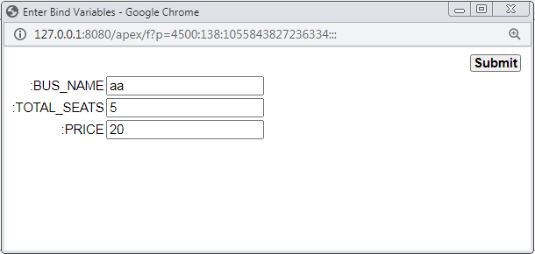

**Bus table :**

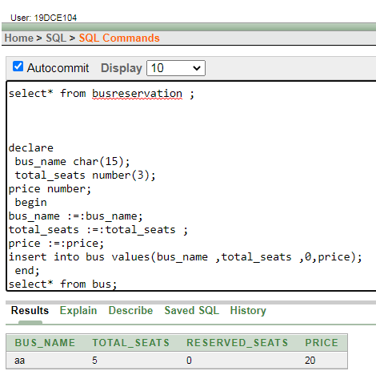

**Bus reservation table :**

declare

bname char(15);

tot number(3);

resv number(3);

p number;

cursor cur is select * from bus;

begin

open cur;

loop

fetch cur into bname,tot,resv,p;

if cur%found then

for i in 1 .. tot loop

insert into busreservation values(bname,i,'n',null);

end loop;

else

exit;

end if;

end loop;

close cur;

end;

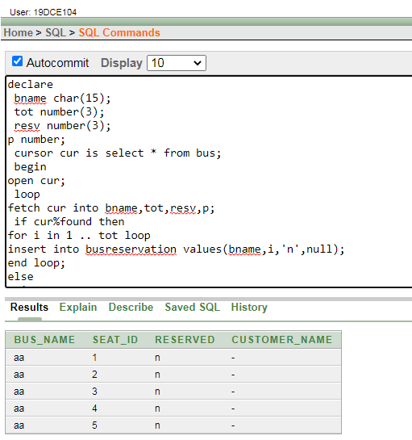**seat reservation code :**

declare

cname char(15);

bname char(15);

sid number(3);

tot number(3);

resv number(3);

totalseat number(2);

cursor c1 is select * from busreservation ;

var c1%rowtype;

begin

cname:= :cname;

bname:=:bname;

totalseat :=:totalseat ;

select total_seats into tot from bus where bus_name=bname;

select reserved_seats into resv from bus where bus_name=bname;

if tot>resv then

for i in 1 .. totalseat loop

select MIN(seat_id) into sid from busreservation where bus_name=bname and reserved='n';

update busreservation set reserved='y' where bus_name=bname and seat_id=sid;

update busreservation set customer_name=cname where bus_name=bname and seat_id=sid;

update bus set reserved_seats=reserved_seats+1 where bus_name=bname;

end loop;

else

dbms_output.put_line('No seat avalable');

end if;

for i in c1 loop

dbms_output.put_line(i.bus_name || ' ' || i.seat_id || ' ' || i.reserved || ' ' || i.customer_name );

end loop;

end;

**Before seat reservation :**



**After seat reservation :**

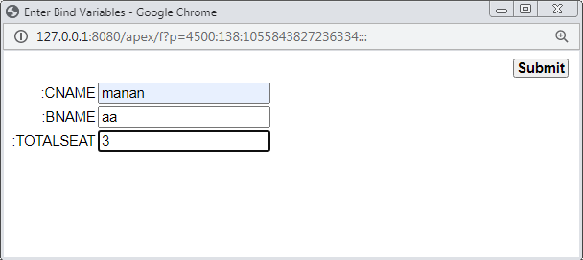

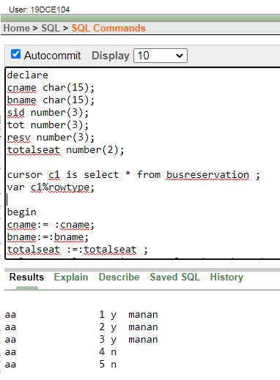

**Bus reservation table after seat reservation :**

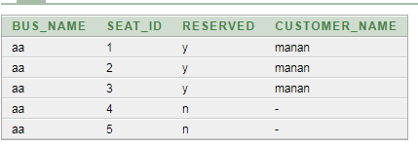

**Bus table after seat reservation :**



**Seat cancellation code :**

declare

cname char(15);

bname char(15);

sid number(3);

resv number(3);

seat number(2);

cursor c1 is select * from busreservation ;

var c1%rowtype;

begin

cname:= :cname;

bname:= :bname;

seat:= :seat;

select reserved_seats into resv from bus where bus_name=bname;

if resv>0 then

for i in 1 .. seat loop

select MAX(seat_id) into sid from busreservation where bus_name=bname and reserved='y'and customer_name=cname;

update busreservation set reserved='n' where bus_name=bname and seat_id=sid;

update busreservation set customer_name=null where bus_name=bname and seat_id=sid;

update bus set reserved_seats=reserved_seats-1 where bus_name=bname;

end loop;

else

dbms_output.put_line('Cancelation not allow');

end if;

for i in c1 loop

dbms_output.put_line(i.bus_name || ' ' || i.seat_id || ' ' || i.reserved || ' ' || i.customer_name );

end loop;

end;

**After seat cancellation:**

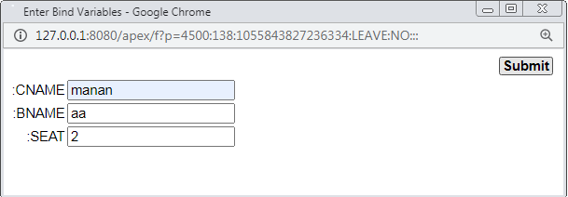

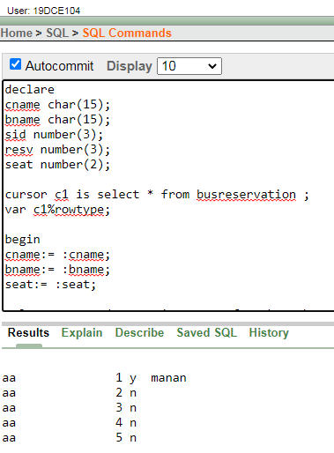

**Bus table after seat cancellation :**



**Bus reservation table after seat cancellation :**

